38.32: 20.66 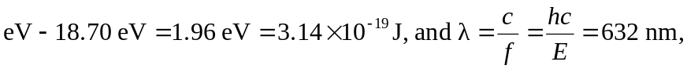in good agreement.

